How to use Xcontrol Chart in Superset

# Run the Superset

## Find a Linux machine, suggest using Ubuntu. Make sure docker and docker compose are available.

## Create a working folder, then open the folder in Terminal.

## Run following commands:

## git clone [https://github.com/**jolin-azeus**/superset.git](https://github.com/jolin-azeus/superset.git)

## cd superset

## sudo docker compose -f docker-compose-image-tag.yml up

## The Superset will be launched through official docker images.

## Try to access: [http://localhost:**8088**/](http://localhost:8088/)

## Login as: admin/admin

## Reference <https://superset.apache.org/docs/installation/docker-compose/#option-3---boot-up-an-official-release>

# Run the PoC

## With the official docker images running, we will run a separated frontend server for the custom visualization.

## Make sure node.js and npm are available.

## Open the working folder in Terminal. Then run following commands:

## cd superset/superset-frontend

## npm install

## npm run dev-server

## Try to access: [http://localhost:**9000**/](http://localhost:9000/)

## Login as: admin/admin

## Reference <https://superset.apache.org/docs/contributing/development#frontend>

# Create a Control Chart in the PoC

## Create a new SQL query with sample sql. Run it, then save as Dataset.



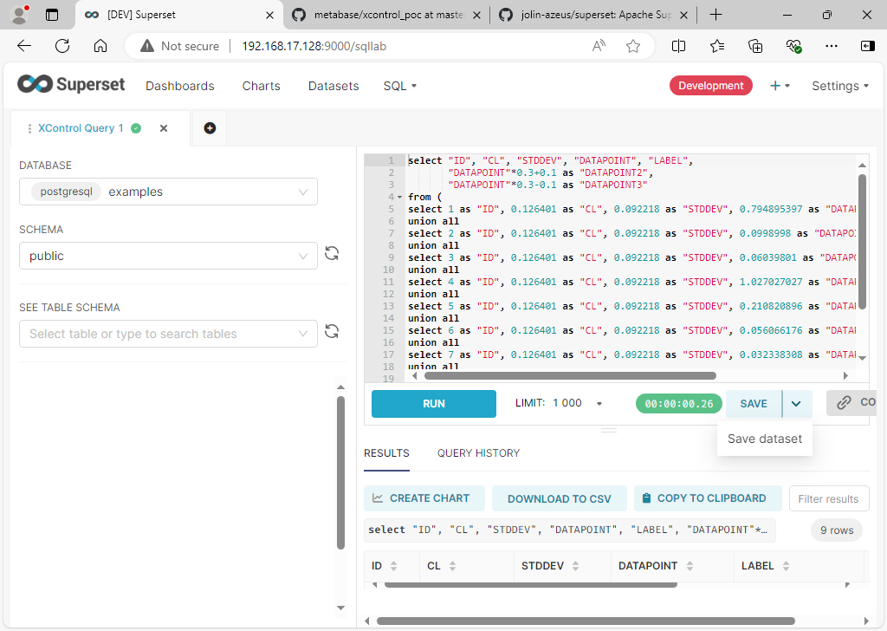

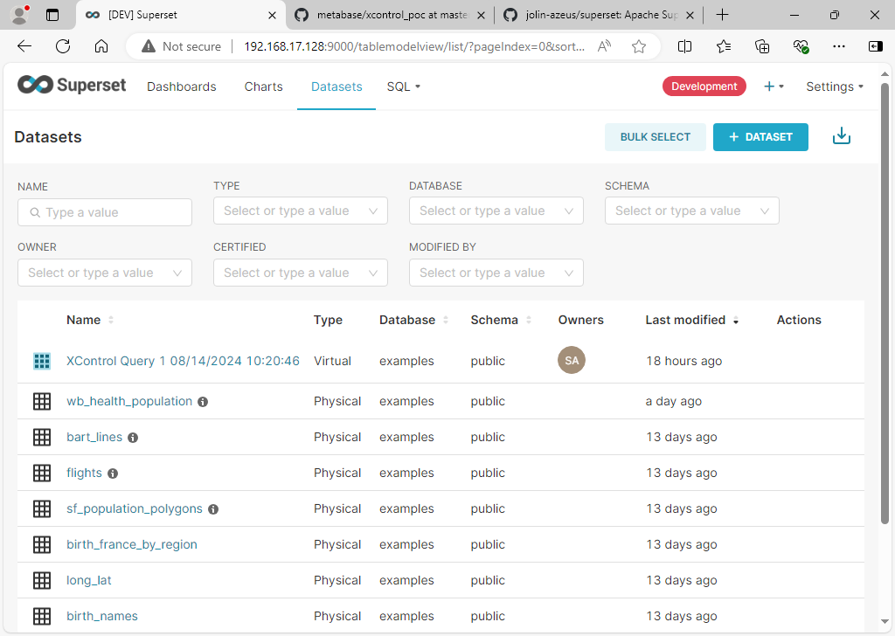

## Create a new chart with the saved Dataset. Choose “Xcontrol Chart” as chart type.

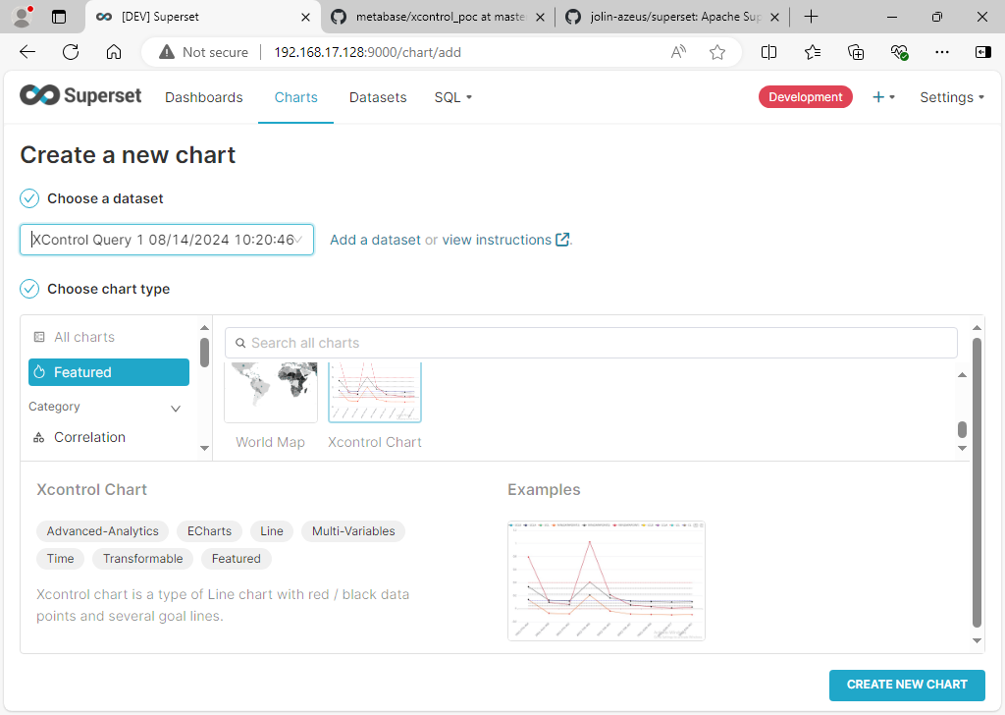

## Fill up “X-axis”, “X-Axis Sort By”, “Metrics”. Please note you need to fille up “Sort by” first, then the “MIN(ID)” will be listed in “X-Axis Sort By”.

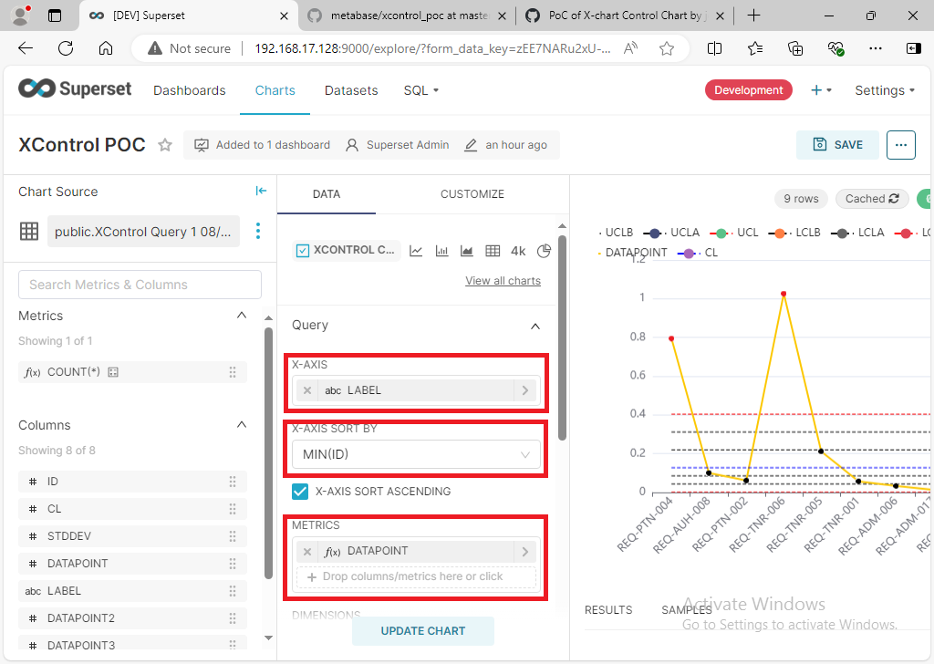

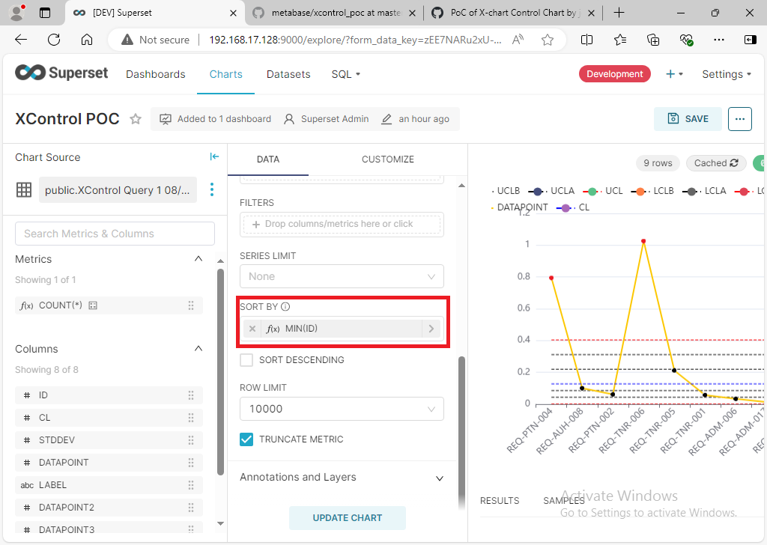

## When adding “Metrics”, can custom the title and expression.

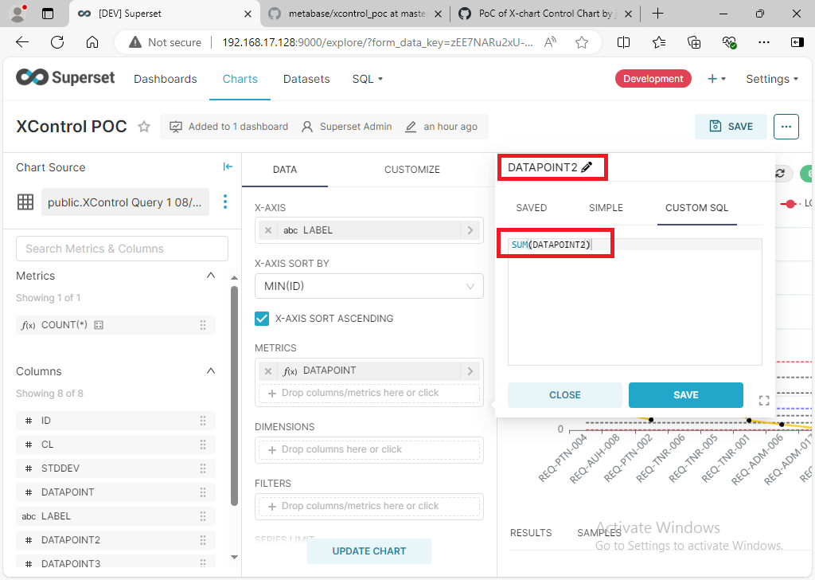

## When multiple “Metrics” are added.

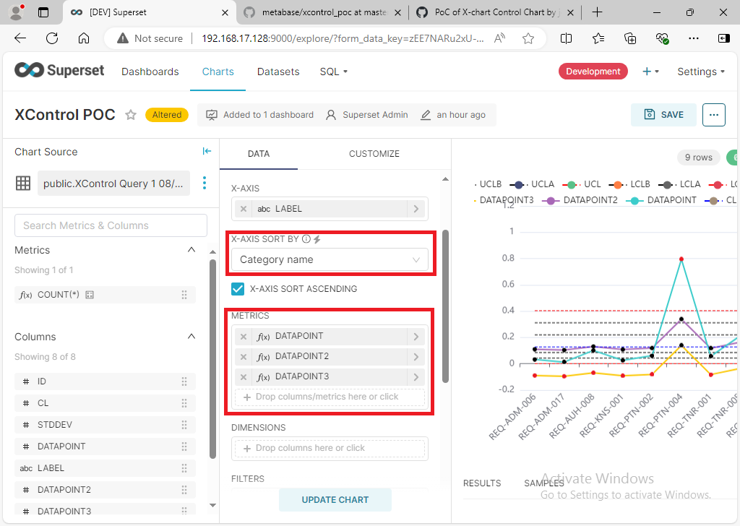

## Other useful settings:

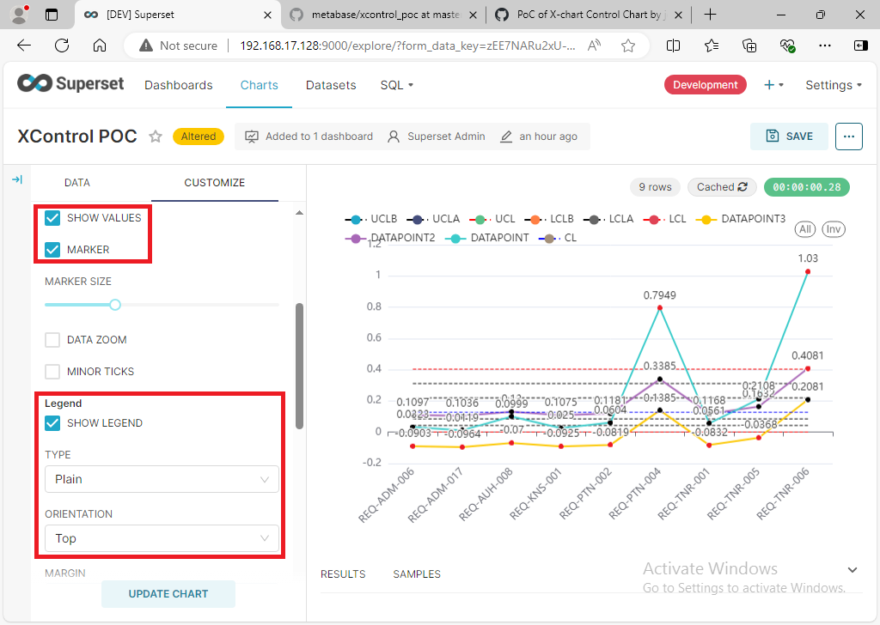

## A sample output from “Download -> Download as image”.

